Practical No:-5
Create a Simple REST Service to demonstrate CRUD operations with “Employee” database. Implement the service with fields viz. Employee_Name, age, Phone_no, Department. Deploy the service and execute the operations.

Step1: Create a datbase and table
mysql> create database employeedb;
mysql> use employeedb;
mysql> create table Employee(
Employee_Name varchar(50),
age int,
Phone_no varchar(15),
Department varchar(50)
);
mysql> show tables;
mysql> desc Employee;
mysql> select * from Employee;
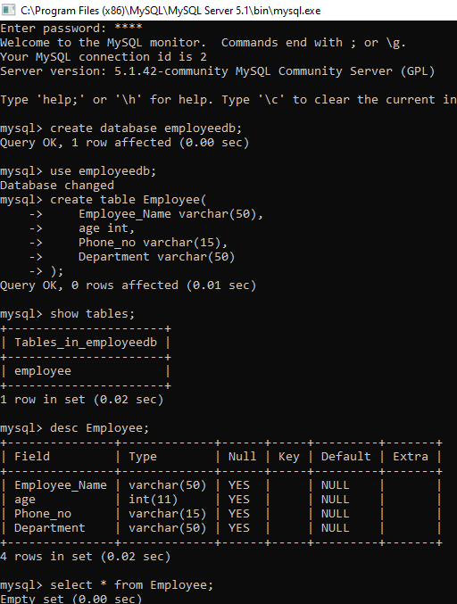

- Insert Data

package ServerPackage;
import javax.ws.rs.core.Context;
import javax.ws.rs.core.UriInfo;
import javax.ws.rs.Produces;
import javax.ws.rs.Consumes;
import javax.ws.rs.GET;
import javax.ws.rs.Path;
import javax.ws.rs.PUT;
import javax.ws.rs.core.MediaType;
import java.sql.*;
@Path("generic")
public class GenericResource {
@Context
private UriInfo context;
public GenericResource() {
}
@GET
@Produces(MediaType.APPLICATION_XML)
public String getXml() {
//TODO return proper representation object
throw new UnsupportedOperationException();
}
@PUT
@Consumes(MediaType.APPLICATION_XML)
public void putXml(String content) {
}
@PUT
@Consumes(MediaType.APPLICATION_XML)
@Path("/ExecuterQuery")
public String executeMyquery(String query)
{
try
{
Class.forName("com.mysql.jdbc.Driver");
String url = "jdbc:mysql://localhost/employeedb";
Connection con = DriverManager.getConnection(url,"root","maha");
Statement st = con.createStatement();
String q = query;
st.execute(q);
st.close();
con.close();
return "Query is Executed!!!";
}
catch (Exception e)
{
return e.getMessage();
}
}
}
Output:-
Insert Query
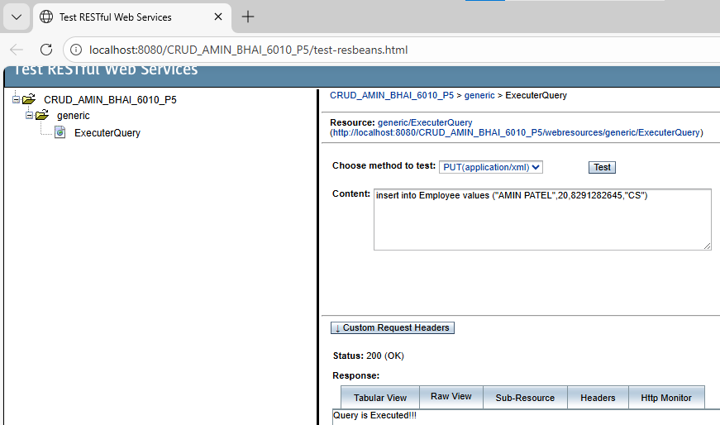
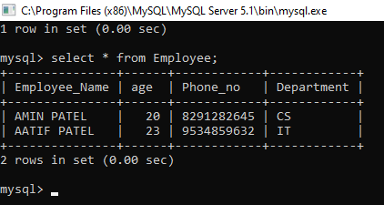

Update Query
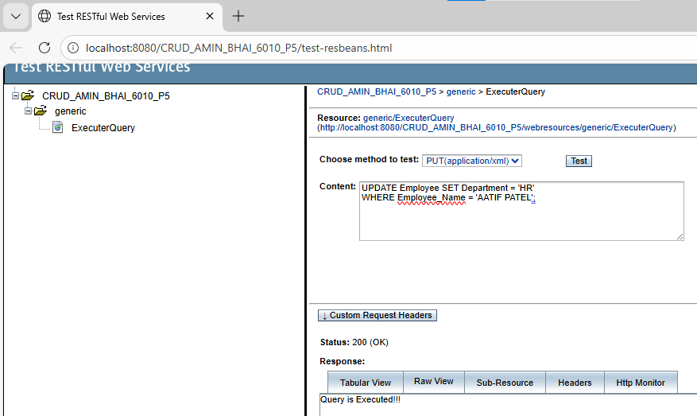

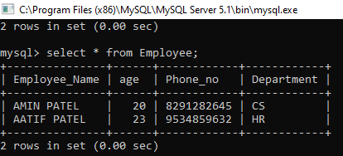

Delete Query
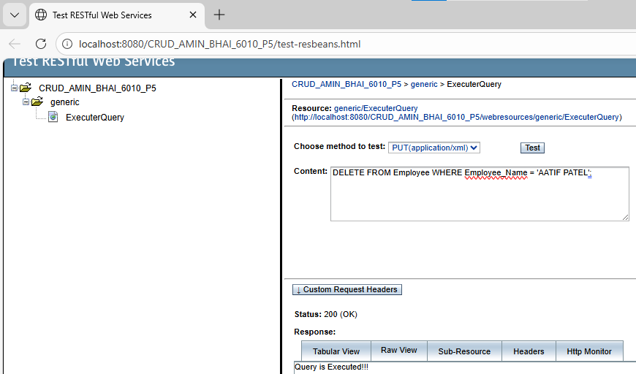

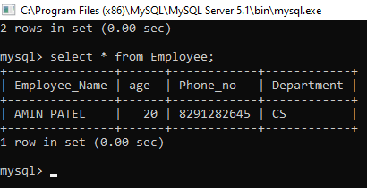

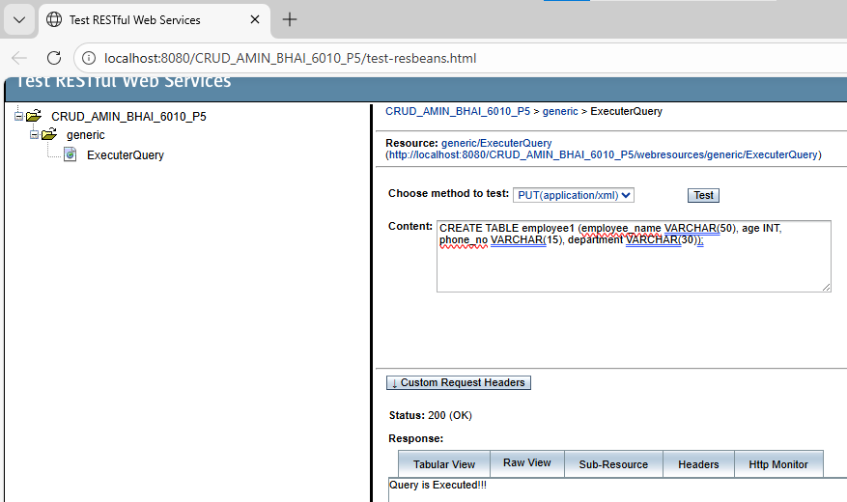
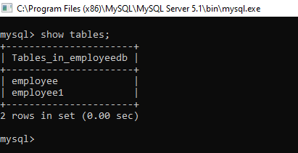

- Retrieve all records

Code:
package ServerPackage;
import javax.ws.rs.core.Context;
import javax.ws.rs.core.UriInfo;
import javax.ws.rs.Produces;
import javax.ws.rs.Consumes;
import javax.ws.rs.GET;
import javax.ws.rs.Path;
import javax.ws.rs.PUT;
import javax.ws.rs.core.MediaType;
import java.sql.*;
@Path("generic")
public class GenericResource {
@Context
private UriInfo context;
public GenericResource() {
}

@GET
@Produces(MediaType.APPLICATION_XML)
public String getXml() {
//TODO return proper representation object
throw new UnsupportedOperationException();
}
@PUT
@Consumes(MediaType.APPLICATION_XML)
public void putXml(String content) {
}
@PUT
@Consumes(MediaType.APPLICATION_XML)
@Path("/ExecuterQuery")
public String executeMyquery(String query)
{
try
{
Class.forName("com.mysql.jdbc.Driver");
String url = "jdbc:mysql://localhost/employeedb";
Connection con = DriverManager.getConnection(url,"root","maha");
Statement st = con.createStatement();
String q = query;
st.execute(q);
st.close();
con.close();
return "Query is Executed!!!";
}
catch (Exception e)
{
return e.getMessage();
}
}
@PUT
@Consumes(MediaType.APPLICATION_XML)
@Path("/GetAllEmployee")
public String GetAllEmployee(String query)
{
try
{
Class.forName("com.mysql.jdbc.Driver");
String url = "jdbc:mysql://localhost/employeedb";
Connection con = DriverManager.getConnection(url,"root","maha");
Statement st = con.createStatement();
String q = query;
String data = "";
ResultSet rs = st.executeQuery(q);
while(rs.next())
{
data = data + rs.getString(1) +" ";
data = data + rs.getString(2) +" ";
data = data + rs.getString(3) +" ";
data = data + rs.getString(4) +" ";
}
st.close();
con.close();
return data;
}
catch (Exception e)
{
return e.getMessage();

}
}
}

Output
